**System Requirements Specifications**

**For**

**Performance Appraisal**

**HR Orbit**

Version No.: 1.0

Date of Release: 08/09/2025

Copy No:



**Sonali Intellect Limited (SIL)**

**Banani, Dhaka**

A. Document Release History 2

B. Circulation Details 4

C. List of Amendments Made on the Previous Version No… 5

1. Introduction 5

1.1 Purpose 6

1.2 Scope 6

1.3 Definitions, Acronyms, and Abbreviations 6

1.4 References 6

2. Overall Description 7

2.1 Product Perspective 7

2.2 Product Functions 7

2.3 User Classes and Characteristics 8

2.4 Operating Environment 8

2.5 Constraints 8

2.6 Assumptions and Dependencies 8

3. System Features 9

3.1 User Authentication and Profile Management 9

3.1.1 Login Page: 9

3.1.2 Forgot/Change Password: 9

3.1.3 User Profile: 9

3.2 Employee Repository Management 9

3.2.1 Admin User Creation: 9

3.2.2 Data Validation: 10

3.2.3 Data Storage: 10

3.3 Performance Appraisal Workflow 10

3.3.1 Form Flow: 10

3.3.2 Role-Based Access: 10

3.3.3 Conditional Hierarchy: 10

3.3.4 Automatic Calculations: 10

3.3.5 Final Decision Table: 10

3.4 Notification System 10

3.4.1 Pending Review Notification: 10

3.4.2 Deadline Notification: 10

3.4.3 Form Access Control: 10

3.4.4 Notification Display: 11

3.5 Document Generation 11

3.5.1 PDF Generation: 11

3.5.2 PDF Content: 11

4. External Interface Requirements 11

4.1 User Interfaces 11

4.2 Software Interfaces 11

5. Non-Functional Requirements 11

5.1 Performance Requirements 11

5.2 Security Requirements 11

5.3 Scalability 12

5.4 Reliability and Availability 12

5.5 Usability 12

6. Diagrams and Data Model 12

6.1 Flow Chart 12

6.2 Activity Diagram 13

6.3 Data Flow Diagram (DFD) 14

6.3.1 Context Diagram/ Level-0 Data Flow Diagram (DFD) 14

6.3.2 Level-1 Data Flow Diagram (DFD) 15

6.3.3 Level-2 Data Flow Diagram (DFD) 16

6.4 Data Model and Schema Design 17

6.4.1 Enhanced Entity Relationship Diagram (EERD) 17

6.4.2 Schema 18

6.4 Class Diagram 19

6.5 Software Architecture Design 20

# Document Release History

|  |  |  |  |  |  |  |  |
| --- | --- | --- | --- | --- | --- | --- | --- |
| **Sl.**  **No.** | **Version Number** | **Release Date** | **Prepared By** | **Reviewed By** | **Approved By** | **Reasons for New Release** | **Template Reference** |
| 1 | 1.0 | 08/09/2025 | Nafisa Ahmed Progga |  |  |  |  |

# Circulation Details

|  |  |  |
| --- | --- | --- |
| **Copy No.** | **Designation of Copy Holder** | **Location of the Copy** |
|  |  |  |

# List of Amendments Made on the Previous Version No…

|  |  |  |  |  |
| --- | --- | --- | --- | --- |
| **Sl.**  **No.** | **Section No./Page No.** | **Description of the amendment** | **Approved by** | **Change Request No. & Date** |
|  |  |  |  |  |

## 1. Introduction

#### 1.1 Purpose

The purpose of this document is to specify the functional and non-functional requirements for the HR Orbit Performance Appraisal System. This web-based application is designed to automate and digitize the performance review process at Sonali Intellect Limited, replacing the current manual, paper-based system. The SRS will serve as a guide for development, testing, and deployment, ensuring the final product meets all business objectives and stakeholder needs.

#### 1.2 Scope

The system will manage the entire performance appraisal lifecycle, from initial employee self-appraisal to final approval by the CEO. It includes user management with role-based access control, a centralized employee data repository, a multi-level appraisal workflow, a real-time notification system, and the capability to generate a final, downloadable PDF of the completed form.

#### 1.3 Definitions, Acronyms, and Abbreviations

* **BRD:** Business Requirements Document
* **BPD**: Business Process Document
* **SRS:** Software Requirements Specification
* **HR:** Human Resources
* **HOD:** Head of Department
* **COO:** Chief Operating Officer
* **CEO:** Chief Executive Officer
* **UI:** User Interface
* **UX:** User Experience
* **PDF:** Portable Document Format
* **SDLC:** Software Development Life Cycle

#### 1.4 References

* Appraisal Form_HR Orbit_Developer__2025.docx
* Employee Supervisor Hierarchy.xlsx
* Meeting Summary_BRD_Draft_Performance Appraisal.pdf
* BRD_Performance Appraisal_HR Orbit.docx
* BPD_Performance Appraisal_HR Orbit.docx
* Scope Document_Performance Appraisal_HR Orbit.pdf
* Data Feild Parameter_Performance Appraisal_HR Orbit.pdf
* Flowchart_Performance_Appraisal.jpg
* Activity Diagram_Performance_Appraisal.jpg
* Context Diagram_Performance Appraisal.png
* Level -1 DFD_Performance Appraisal.png
* Level -2 DFD_Performance Appraisal.jpg
* Enhanched Entity Relationship Diagram ( EERD )_Performance Appraisal.png
* Schema Design_Performance Appraisal.png
* Class Diagram_Performance Appraisal.png
* Software Architecture Design_Performance Appraisal.png

## 2. Overall Description

#### 2.1 Product Perspective

The HR Orbit Performance Appraisal System is a standalone web application. It will be hosted on the sonaliintellect.com domain. The system's primary function is to replace the manual process with a secure, digital workflow.

#### 2.2 Product Functions

The system will provide the following main functions:

* Secure user authentication for multiple roles.
* Management and storage of a central employee data repository.
* Download each employee's details as PDF or excel document.
* A digital performance appraisal form that progresses through a predefined hierarchy.
* Role-based edit and view permissions for the appraisal form.
* Automated calculation of salary and increment based on HR input.
* A real-time notification system for pending tasks and deadlines.
* Generation of the final, completed appraisal form as a PDF document.

#### 2.3 User Classes and Characteristics

The system will serve the following user roles, each with specific access rights:

* **Admin (HR):** Full access to create employee accounts, manage the employee repository, basic salary input for further calculation, download employee details and download completed appraisal forms.
* **Employee:** Can view and edit their own appraisal form (self-appraisal section) and view remarks from subsequent reviewers (Manager to CEO).
* **Manager:** Can view their supervisees' forms and provide input on their designated sections. They can also view their own form.
* **HOD, COO, CEO:** Can view the forms of employees under their review and provide final remarks and decisions on promotion and increment. They have view-only access to all previous sections of the form.

#### 2.4 Operating Environment

* **Backend:** Django
* **Frontend:** React
* **Database:** PostgreSQL
* **Deployment:** GitLab, Docker, Jenkins, Kubernetes
* **Web Browsers:** Compatible with all major modern browsers (Chrome, Firefox, Edge, Safari).

#### 2.5 Constraints

* The system must follow a strict SDLC process as defined in the BRD.
* The front-end must be built using React.
* The system must be accessible via the sonaliintellect.com domain.
* The hierarchy of the appraisal flow is predefined but must be configurable by the Admin/HR for each employee.
* The system must adhere to specific security standards (see Section 5).

#### 2.6 Assumptions and Dependencies

* All users will have access to a supported web browser and an internet connection.
* Each employee's details should be generated in a specific PDF document or excel spreadsheet document.
* The final signed appraisal form must be generated in a specific PDF format.

## 3. System Features

#### 3.1 User Authentication and Profile Management

##### 3.1.1 Login Page:

* The system shall provide a secure login page with fields for Employee Email and Password.
* The login page shall include a "Forgot Password" link.
* The system shall validate credentials against the employee repository.

##### 3.1.2 Forgot/Change Password:

* The "Forgot Password" functionality shall send a password reset link to the user's registered email address.
* The password reset form shall require a new password and a confirmation of the new password.
* A "Change Password" option shall be available on the user's profile page, requiring the old password, new password, and confirmation.

##### 3.1.3 User Profile:

* The system shall display a user profile page with all information from the employee repository.
* The employee shall be able to edit specific fields on their profile page (e.g., Responsibilities, Previous Working Experience, Educational Qualification, Professional Certificate, Image Upload). All other fields (Employee ID, Name, Designation, Department, Joining Date, Grade, Reporting Manager) will be read-only for the employee.

#### 3.2 Employee Repository Management

3.2.1 Admin User Creation: The Admin (HR) shall have the capability to create new user accounts by inputting the following information:

* + Employee ID (text)
  + Name (text)
  + Designation (dropdown)
  + Department (dropdown)
  + Joining Date (date)
  + Grade (text)
  + Salary (number)
  + Reporting Manager (text)

3.2.2 Data Validation: The system shall validate all input fields to ensure data accuracy before saving.

3.2.3 Data Storage: The system shall maintain a centralized database of all employee information.

#### 3.3 Performance Appraisal Workflow

3.3.1 Form Flow: The digital appraisal form shall follow a predefined hierarchical flow:

* + Employee (self-appraisal)
  + Manager
  + HR
  + HOD
  + COO
  + CEO

3.3.2 Role-Based Access: Each role in the hierarchy shall have EDIT access only to their specific section of the form. They shall have VIEW access to all other sections that precede them in the hierarchy.

3.3.3 Conditional Hierarchy: The Admin (HR) shall be able to configure the hierarchy for each employee, marking levels as "optional," "not necessary," or "mandatory."

3.3.4 Automatic Calculations: When the HR inputs the basic salary, the system shall automatically calculate the gross salary and increment.

3.3.5 Final Decision Table: The HOD, COO, and CEO shall be presented with a decision table to recommend promotion, increment, or pay progression.

#### 3.4 Notification System

3.4.1 Pending Review Notification: The system shall send a notification to the next person in the hierarchy when a form is submitted by the previous reviewer.

3.4.2 Deadline Notification: A notification shall be sent to the employee and all reviewers one week before the form submission due date.

3.4.3 Form Access Control: After the submission deadline, view and edit access to the form shall be closed.

3.4.4 Notification Display: Notifications shall appear as pop-up alerts on the dashboard.

#### 3.5 Document Generation

3.5.1 PDF Generation: The system shall provide an option for the Admin (HR) to download the final, completed appraisal form as a PDF document. The system shall also provide an option for HR to download each employee’s details as PDF or excel document.

3.5.2 PDF Content: The generated PDF shall include all data, remarks, and signatures from each reviewer in the hierarchy.

## 4. External Interface Requirements

#### 4.1 User Interfaces

* **Dashboard:** The dashboard shall feature a left menu for the appraisal form, a central area to display the form, and a right panel to list pending review forms for the logged-in user's supervisees.
* **Forms:** All forms shall be intuitive and align with the provided UI/UX designs. Fields shall correspond to those defined in the Data Feild Parameter_Performance Appraisal_HR Orbit.
* **Notifications:** A notification icon shall be displayed in the top-right corner of the navbar.

#### 4.2 Software Interfaces

* **Email Service:** The system shall interface with an email service to send password reset links.

## 5. Non-Functional Requirements

#### 5.1 Performance Requirements

* The system shall load pages and forms within 3 seconds under normal network conditions.
* The system shall handle at least 60 concurrent users without significant degradation of performance.

#### 5.2 Security Requirements

* The system shall be developed following OWASP secure coding guidelines.
* Data transmitted between the client and server shall be encrypted end-to-end.
* User authentication shall include a two-factor authentication provision.
* All data stored in the database shall be encrypted.
* The system shall have an audit trail and logging features for all administrative activities (e.g., creation, modification, deletion of data).
* Access shall be restricted based on user roles and permissions.

#### 5.3 Scalability

* The system architecture shall be scalable to accommodate future growth in the number of employees and organizational hierarchy levels.

#### 5.4 Reliability and Availability

* The system shall be available with a minimum uptime of 99.5%.
* Automated data backup provisions should be in place to prevent data loss.

#### 5.5 Usability

* The system UI shall be user-friendly, consistent, and easy to navigate for all user roles.

## 6. Diagrams and Data Model

The following diagrams provide a visual representation of the system's architecture, data flows, processes, and database structure.

#### 6.1 Flow Chart

The **Flowchart** illustrates the sequential steps in the performance appraisal process, from the initial form submission by the employee to the final approval by the CEO.

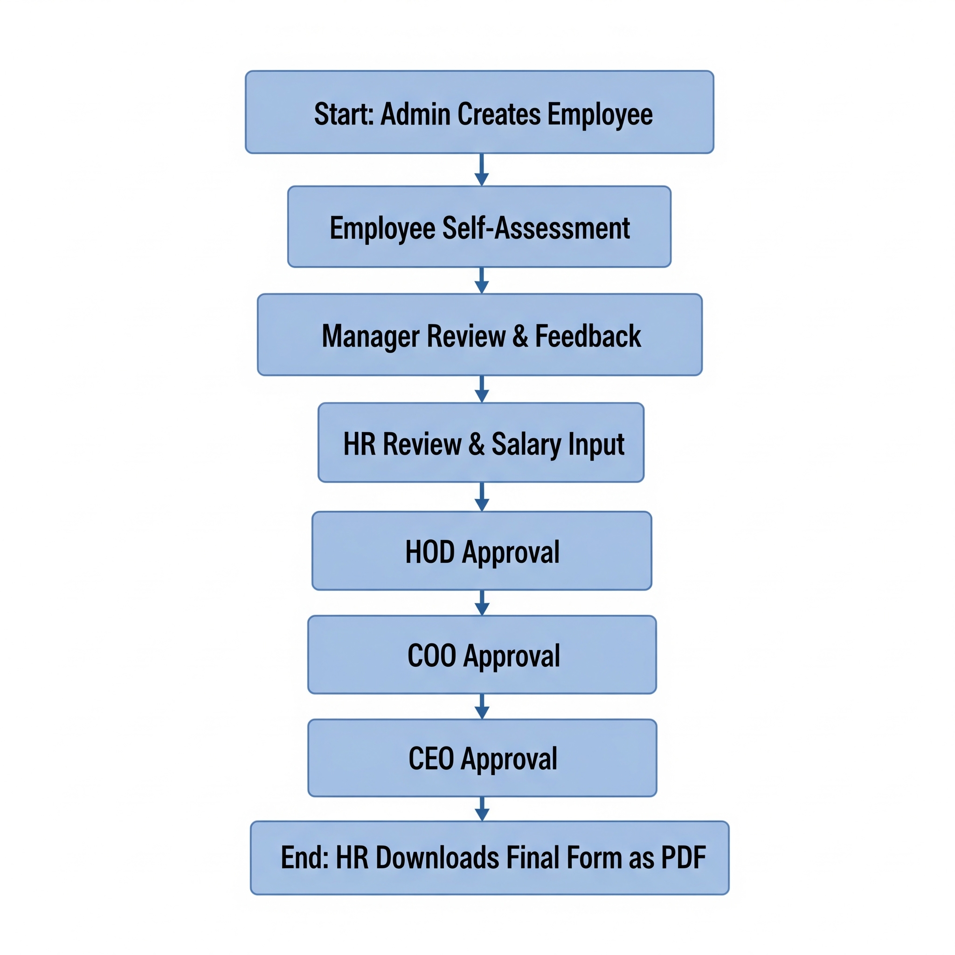

#### 6.2 Activity Diagram

The activity diagram models the sequential and parallel workflows within the HR Orbit Performance Appraisal System. It visually represents the dynamic behavior of the system, illustrating the flow of control from one activity to another. This diagram highlights the steps, actions, and decisions involved in the entire appraisal process, from the initial login and form submission by an **Employee** to the final approval by the **CEO**.

It details how the appraisal form progresses through the various hierarchical levels - including **Manager**, **HR**, **HOD**, and **COO**—and shows the conditional logic (e.g., promotion recommendations) and parallel activities that occur at each stage. The diagram provides a clear, step-by-step visualization of the business process, ensuring all stakeholders have a shared understanding of the system’s operational flow.

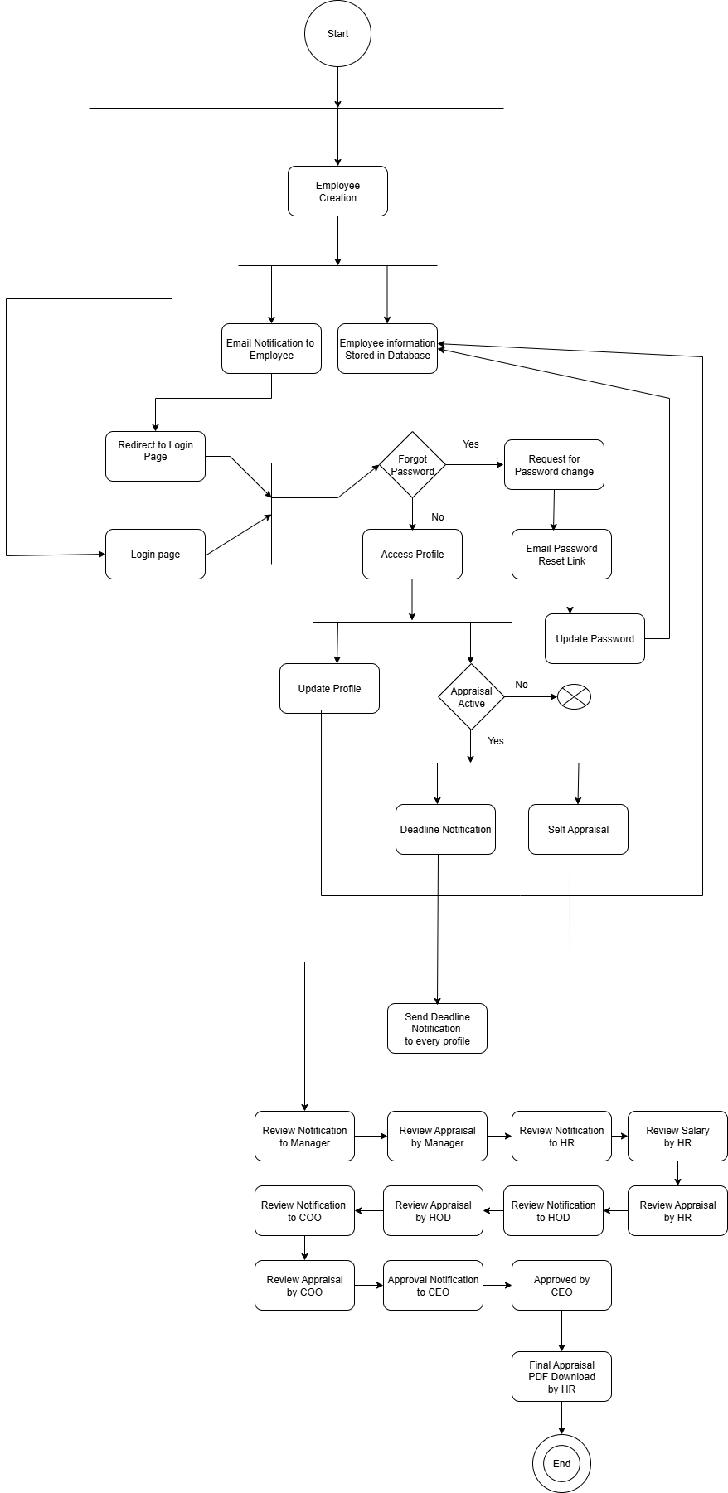

#### 6.3 Data Flow Diagram (DFD)

##### 6.3.1 Context Diagram/ Level-0 Data Flow Diagram (DFD)

The **Context Diagram** (a Level-0 DFD) shows the entire Performance Appraisal System as a single process, highlighting the flow of information between the system and external entities such as the Employee, Manager, HR, HOD, COO and CEO.

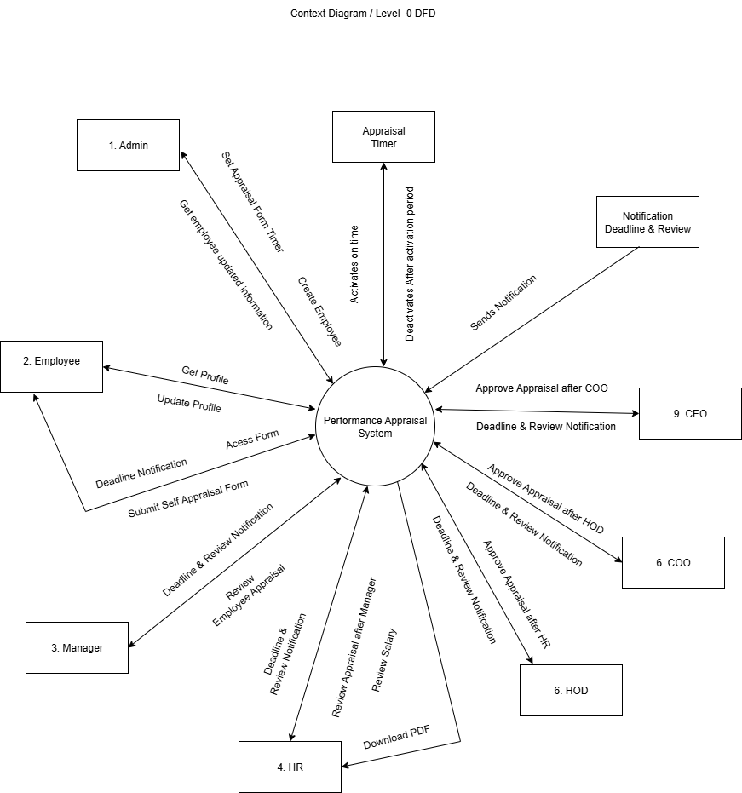

##### 6.3.2 Level-1 Data Flow Diagram (DFD)

The **Level-1 DFD** breaks down the system into its primary processes, including Employee Repository Management, the Appraisal Workflow, and the Notification system.

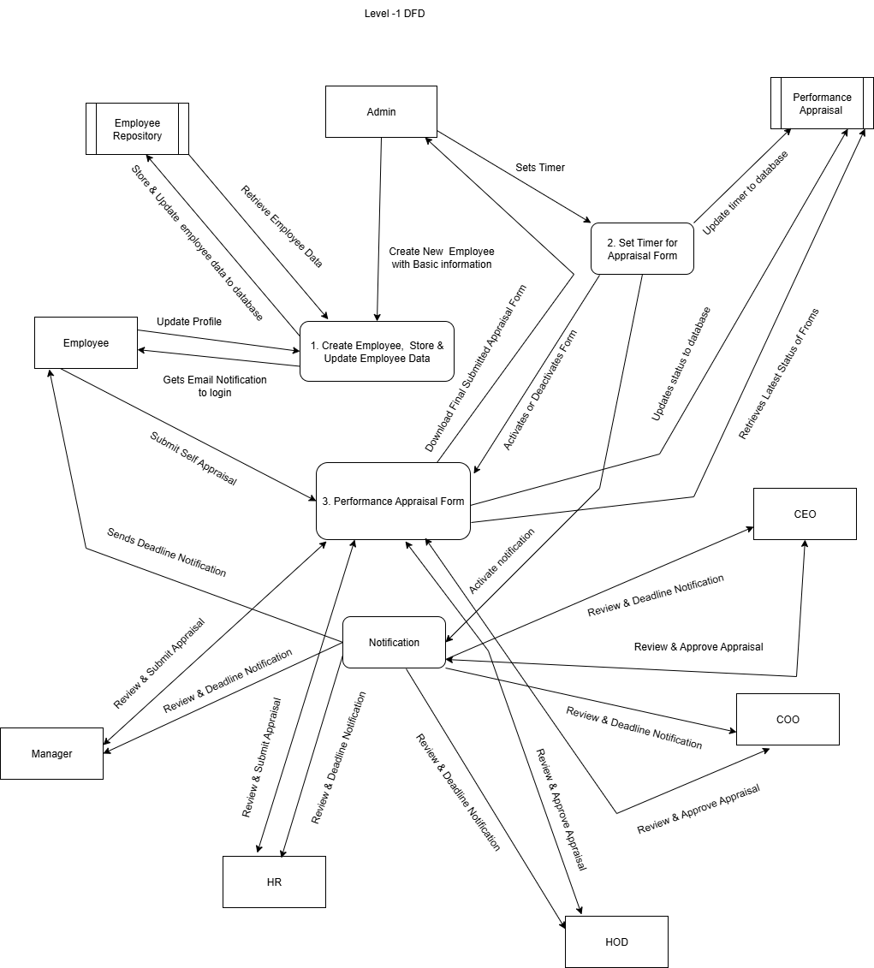

##### 6.3.3 Level-2 Data Flow Diagram (DFD)

The **Level-2 DFD** provides a more detailed view of specific processes, such as the appraisal workflow, showing the data stores and sub-processes involved.

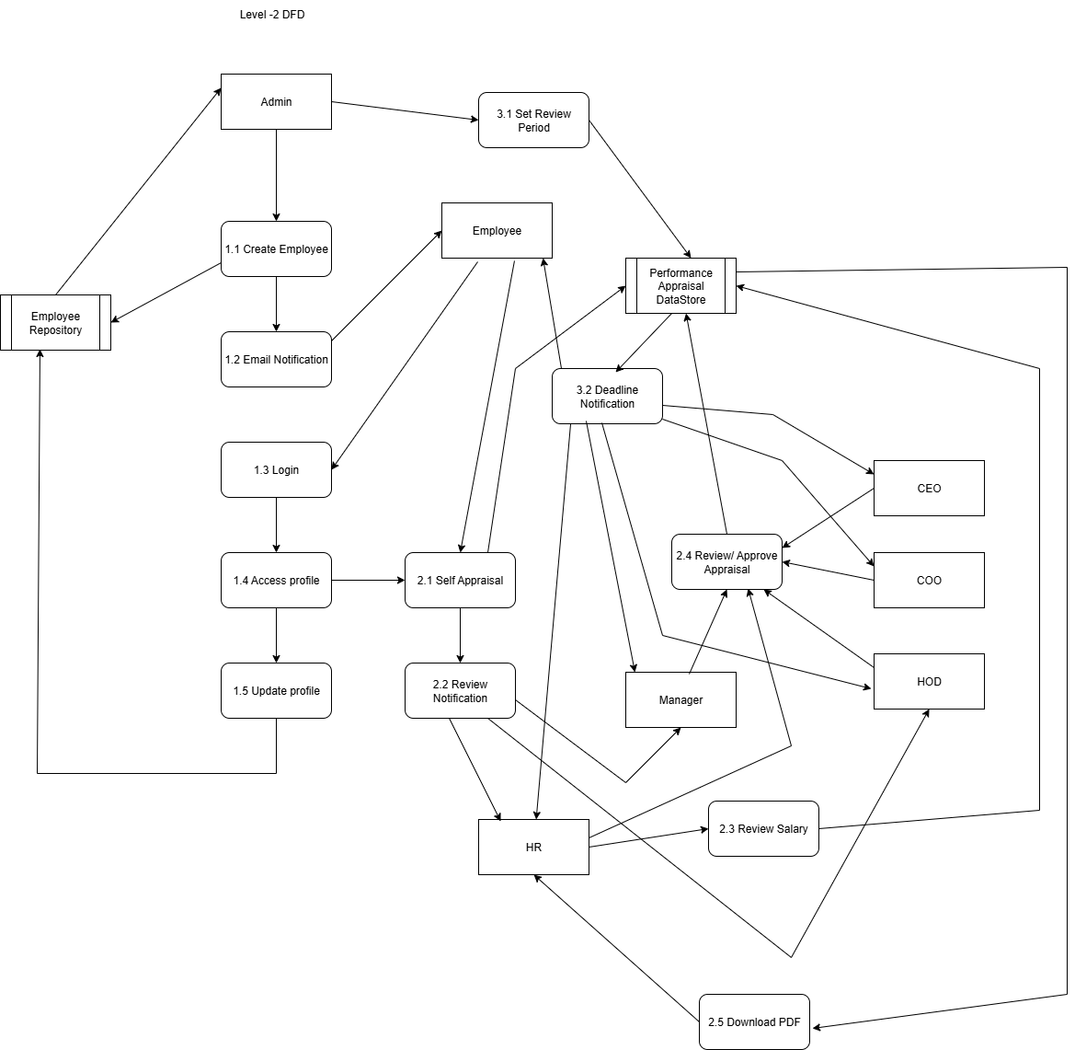

#### 6.4 Data Model and Schema Design

##### 6.4.1 Enhanced Entity Relationship Diagram (EERD)

The **Enhanced Entity Relationship Diagram (EERD)** visually represents the data entities, their attributes, and the relationships between them. This includes entities like User, Employee, AppraisalForm, and DecisionTable.

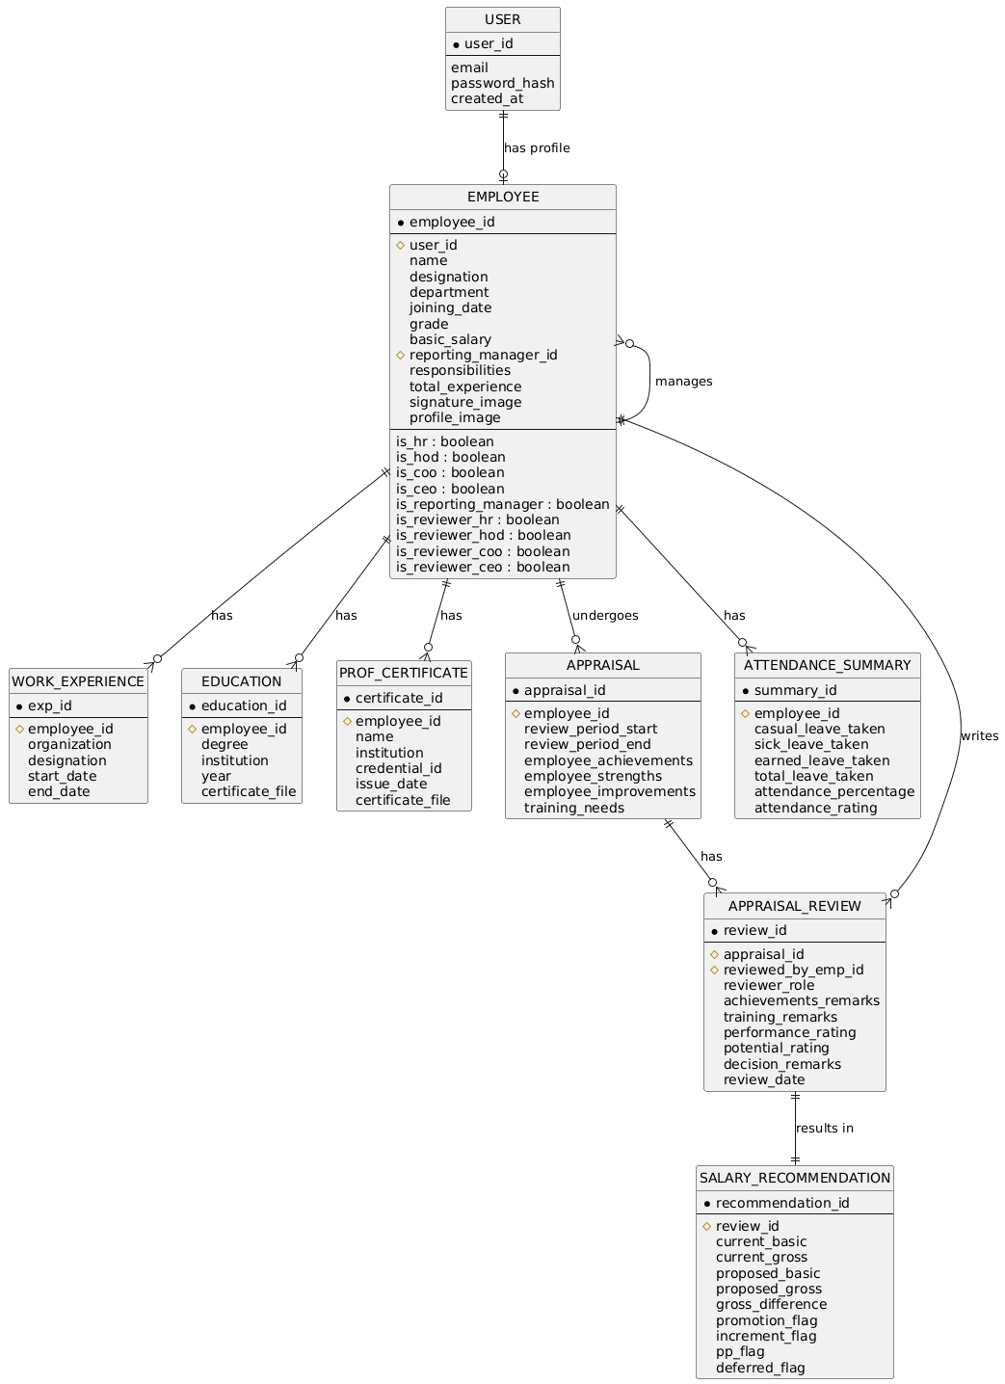

##### 6.4.2 Schema

Schema **Design** provides the logical database structure, detailing the tables, fields, and their data types, as derived from the EERD.

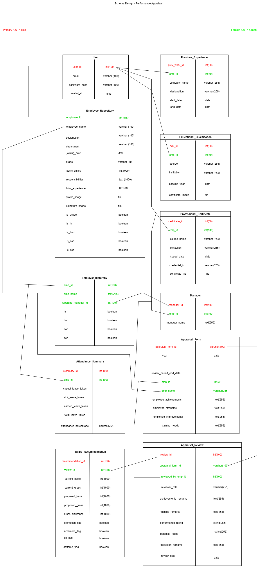

#### 6.4 Class Diagram

The **Class Diagram** presents the static structure of the system by showing the classes, their attributes, methods, and the relationships (like inheritance, association, and aggregation) between them. It outlines the blueprints for the software components.

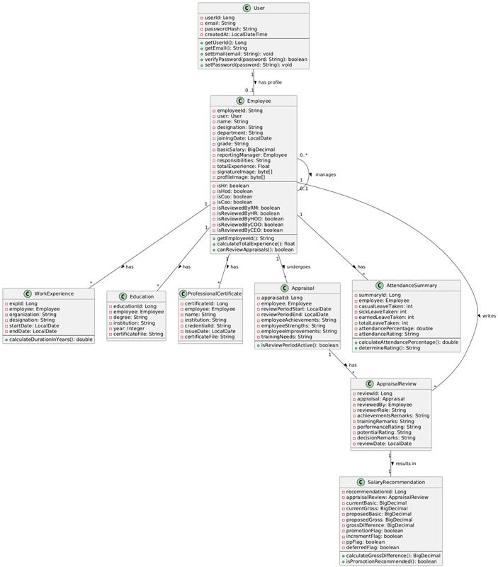

#### 6.5 Software Architecture Design

The **Software Architecture Design** diagram provides a high-level overview of the system's structure. It outlines the system components, the relationships between them, and the principles that guide its design, showing how different modules (e.g., frontend, backend, database) interact.